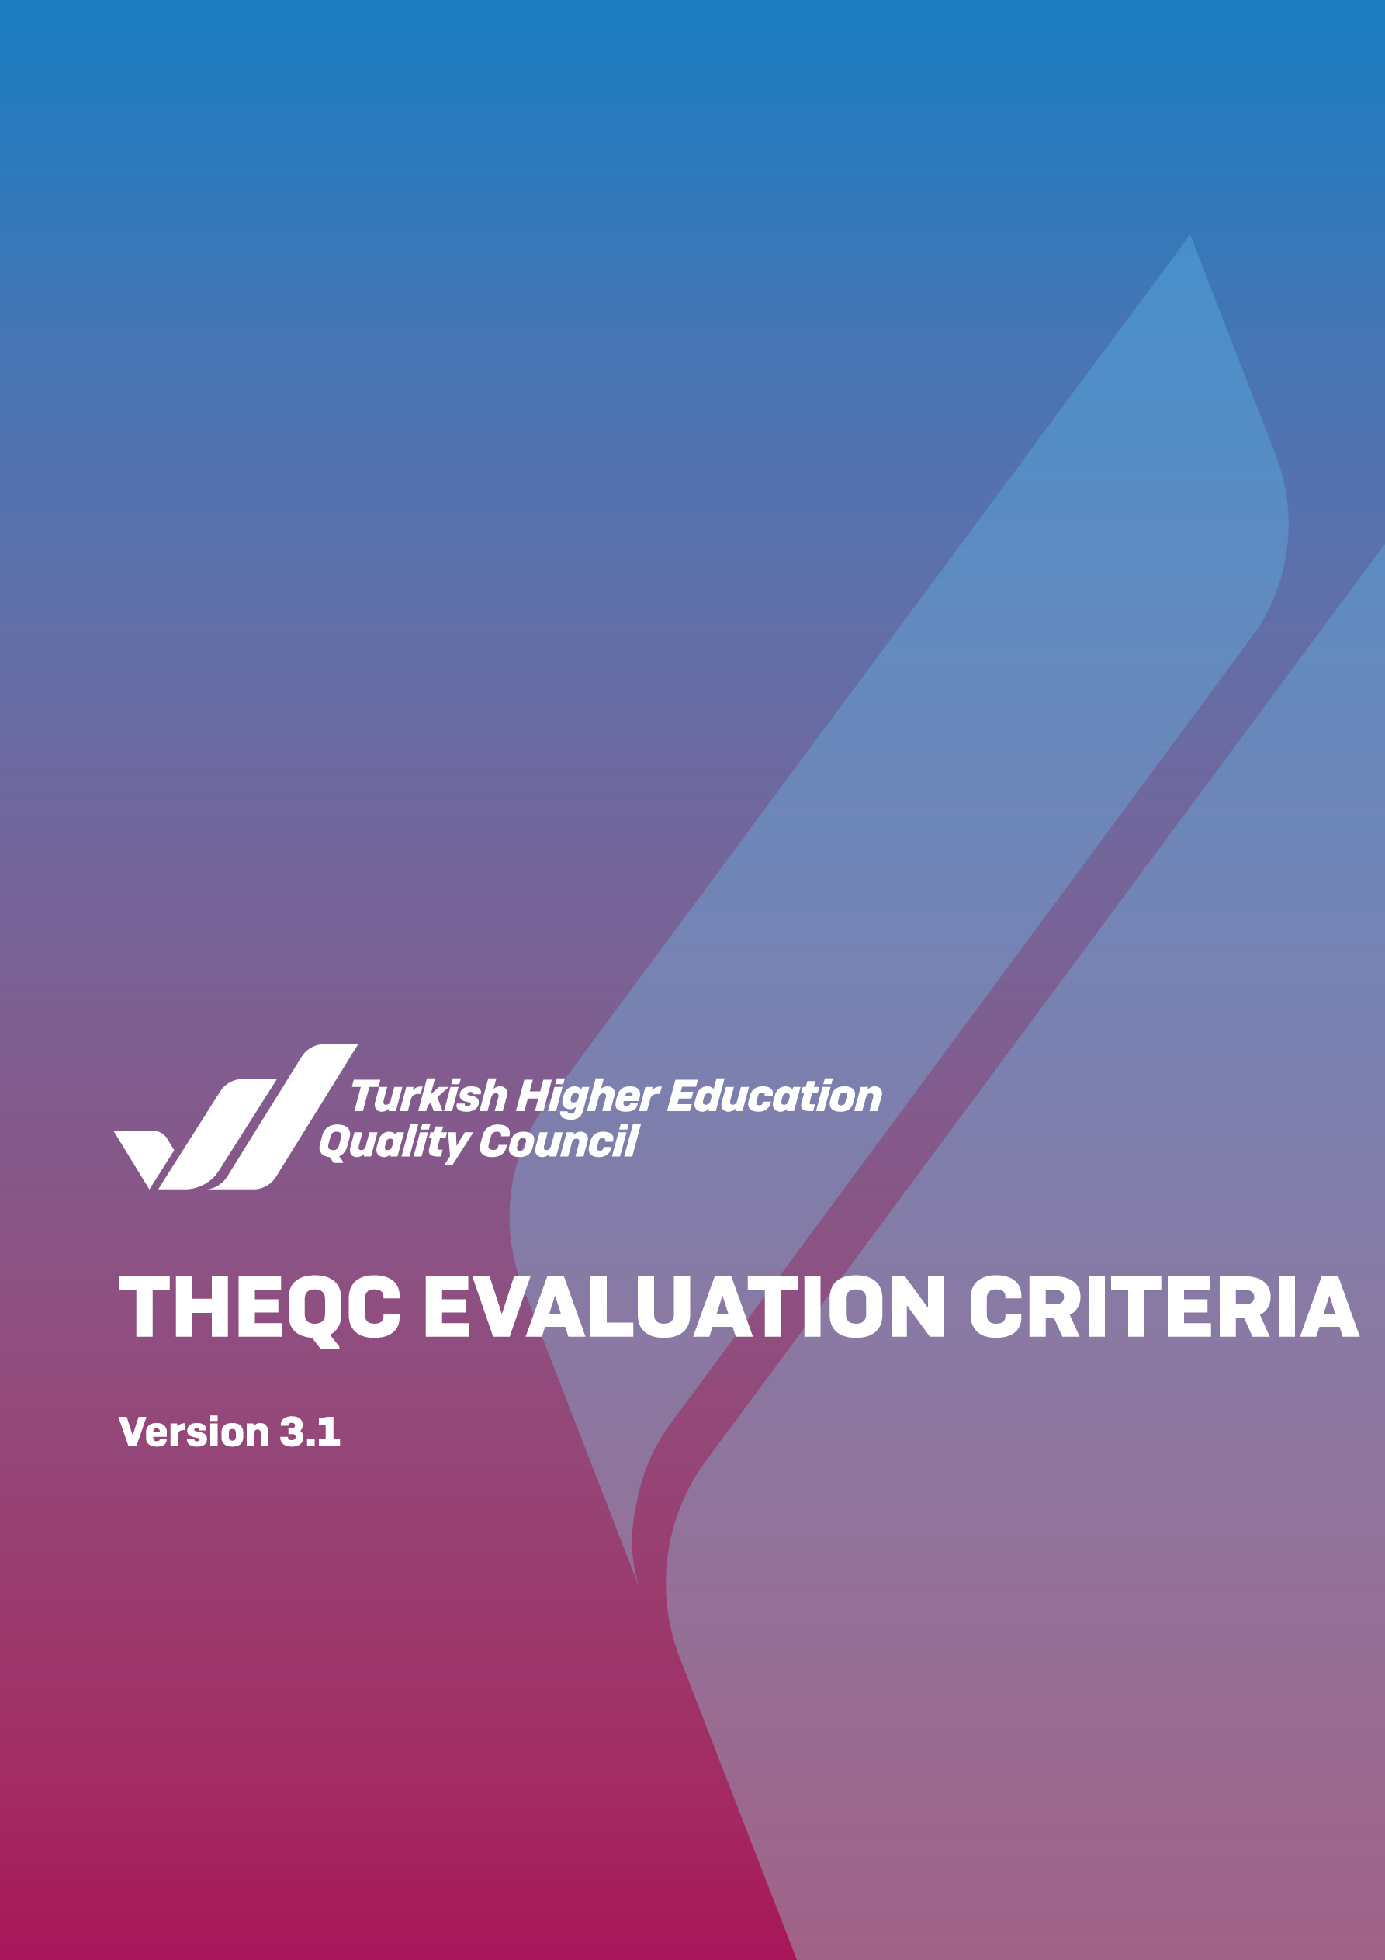

THEQC EVALUATION CRITERIA

(VERSION 3.1)

These criteria have been updated considering the Standards and Guidelines for Quality Assurance in the European Higher Education Area (ESG-2015) to be used in the THEQC Evaluation Programs (Institutional External Evaluation Program, Follow-up Program, Institutional Accreditation Program, and Mid-term Evaluation Program).

Table 1 shows the relevance between ESG-2015 and the THEQC Evaluation Criteria.

1. LEADERSHIP, GOVERNANCE and QUALITY
   1. Leadership and Quality

The institution should have the governance model to enable institutional transformation, apply leadership approaches, create internal quality assurance mechanisms and internalize the quality assurance culture.

* 1. Mission and Strategic Goals

The institution should plan and implement its strategic goals and objectives created in accordance with its policies to achieve its vision, mission, and goals, monitor and evaluate its results in the scope of performance management, and disclose these to the public.

* 1. Governance Systems

The institution should have a system to manage its processes as well as financial, human and information resources to guarantee the achievement of its strategic objectives in qualitative and quantitative manners.

* 1. Stakeholder Involvement

The institution should establish and manage the necessary systems to receive and respond to the feedback of its internal and external stakeholders in order to ensure their involvement in strategic decisions and processes and use them in their decisions.

* 1. Internationalization

The institution should manage its processes, form the organizational structure, and periodically monitor and evaluate its results in accordance with its internationalization strategy and objectives.

1. LEARNING AND TEACHING
   1. B1. Program Design, Evaluation and Update

The institution should design its teaching programs in line with the Turkish Higher Education Qualifications Framework, the teaching objectives, and learning outcomes and periodically evaluate and update them to ensure that they meet the needs of students and society.

* 1. Implementation of Programs (Student-Centered Learning, Teaching and Evaluation)

The institution should implement the student-centered and competency-based teaching, measurement and evaluation methods to achieve the aimed qualified alumni competencies. The institution should set out explicit criteria for student admissions, the recognition and certification of degrees, diplomas and other qualifications and consistently implement the predefined and announced rules.

* 1. Learning Resources and Academic Support Services

The institution should have the necessary resources, infrastructure and environment to implement its learning and teaching activities and achieve its aim of qualified alumni competencies and should ensure that the learning opportunities are sufficient and accessible for all students. The institution should provide assistance services for the academic development and career planning of students.

* 1. Teaching Staff

The institution should be fair and transparent in all the processes pertaining to the recruitment, appointment, promotion and teaching assignments of the teaching staff. The institution should provide opportunities to continuously develop the learning and teaching competencies of teaching staff to achieve the aim of qualified alumni competencies.

1. RESEARCH AND DEVELOPMENT

(Artistic activities are also evaluated within this scope under the Research and Development heading in the higher education institutions which offer art education degrees.)

* 1. Management of Research Processes and the Research Resources

The institution should manage its research activities in a way that is aligned with its academic priorities determined within the framework of its strategic plan as well as the local, regional and national development objectives; adds value; and can be transformed into social benefit. The institution should provide the required physical infrastructure and financial resources for these activities and enable their effective use.

* 1. Research Competence, Collaborations, and Supports

The institution should give opportunities (training, collaborations, supports, etc.) to teaching staff and researchers to maintain and improve their scientific research competence.

* 1. Research Performance

The institution should periodically measure and evaluate its research activities on the basis of data and publish their results. The obtained data should be employed for the periodic review and continuous improvement of the institution's research and development performance.

1. SERVICE TO SOCIETY
   1. Management of Service to Society Processes and the Service to Society Resources

The institution should manage its service to society activities in accordance with its strategic objectives and goals. The institution should provide the required physical infrastructure and financial resources for these activities and enable their effective use.

* 1. Service to Society Performance

The institution should periodically review and continuously improve the activities it maintains in line with its service to society strategy and objectives.

Table 1. The relevance between ESG-2015 and the THEQC Evaluation Criteria

|  |  |  |
| --- | --- | --- |
| The THEQC Evaluation Criteria | | Standards in Part 1 of ESG |
| A.LEADERSHIP, GOVERNANCE AND QUALITY | * 1. Leadership and Quality   2. Mission and Strategic Goals   3. Governance Systems   4. Stakeholder Involvement   5. Internationalization | 1.1. Policy for Quality Assurance   * 1. Information Management   2. Public Information   1.10. Cyclical External Quality Assurance |
| B. LEARNING AND TEACHING | * 1. B1. Program Design, Evaluation and Update   2. Implementation of Programs (Student-centered Learning, Teaching and Evaluation)   3. Learning Resources and Academic Support Services   4. Teaching Staff | * 1. Design and Approval of Programmes   2. Student-centred Learning, Teaching and Assessment   3. Student Admission, Progression, Recognition and Certification   4. Teaching Staff   5. Learning Resources and Academic Support Services   1.9. On-going Monitoring and Periodic Review of Programmes |
| C. RESEARCH AND DEVELOPMENT | * 1. Management of Research Processes and the Research Resources   2. Research Competence, Collaborations, and Supports   3. Research Performance |  |
| D. SERVICE TO SOCIETY | D.1. Management of Service to Society Processes and the Service to Society Resources  D.2 Service to Society Performance |  |

